“Together for Life!” Mandeville Life Chain - January 22, 2022
Mandeville - Life Chain Event

10:00 - Noon
Location - Highway 190 between St. Ann Drive/Meadowbrook Blvd and Causeway/Hwy 190 Off-Ramp / N. Causeway On-Ramp (at the Causeway overpass) – see attached map. We will meet prior to the event, beginning at 9:30, to distribute pro-life signs:
- Behind Chase Bank
3481A E Causeway Approach, Mandeville, LA.
- Next to El Paso Mexican Grill
3410 U.S. Hwy 190, Mandeville, LA 70471
- Next to Bippo’s Place for Smiles
2935 U.S. Hwy 190, Mandeville, LA 70471
- Between Starbucks & Party City
3601 & 3371 U.S. Hwy 190, Mandeville, LA 70471
Note: These locations are marked as purple dots on the map below.
After the event, we will collect the signs at these same locations for reuse at future events.

Join Our Lady of the Lake Knights of Columbus (Council 9240) & Respect for Life Ministry as we stand for life along the roadside waving signs in the form of “life chains,” serving as a witness for the unborn and their mothers to share our pro-life message with fellow citizens. We will be joining other communities across Louisiana who will be conducting “life marches” as well.
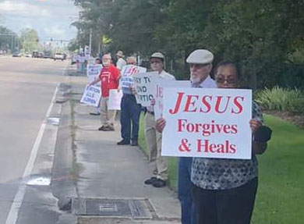
The City of Mandeville has requested that we not 1) block the highway or intersections and 2) stand behind the sidewalk as to not obstruct pedestrian use.
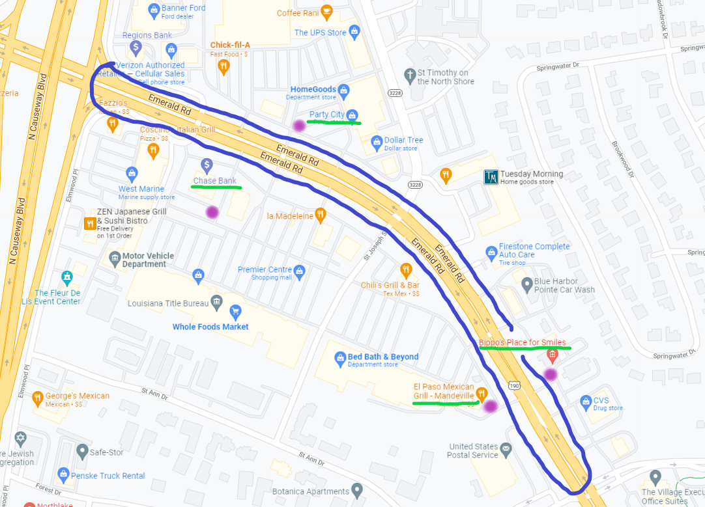

For more information contact John Lodge at JW-TCLODGE@att.net.

