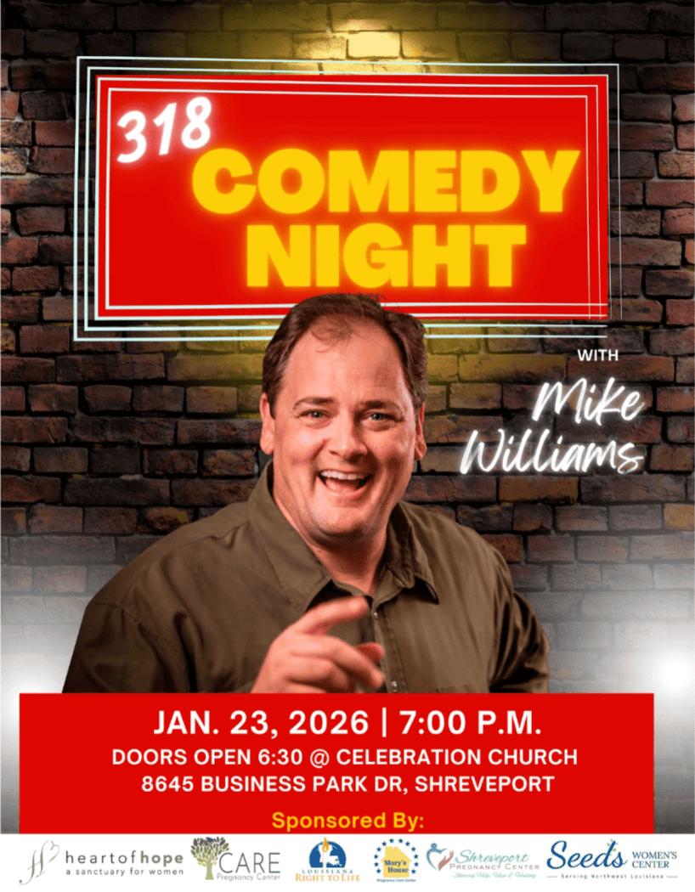
Platinum Sponsor $1,000
*Corporate or personal name included in advertising, *16 seats with reserved premier Seating, Mike Williams signed book, *name displayed as presenting sponsor at event, and in social media.

Gold Sponsor $750
*Corporate or personal name included in advertising, 12 seats with reserved premier seating *name displayed as sponsor at event, and in social media.

Silver Sponsor $500
*Corporate or personal name included in advertising, 8 seats with reserved seating *name displayed as sponsor at Event, and in social media

Bronze Sponsor $250
6 seats with reserved seating, and name or business on social media

Life Sponsor $100
4 tickets with reserved seating

Please complete ALL information below:

Company or Individual Name: __________________________________________________ _____________________________________________________________________________
Mailing Address: _____________________________________________________________
Email: __________________________________ Phone number: ______________________

Sponsorship Levels □$1,000 □$750 □$500 □$250 □$100

□ I would like to donate a gift other than the amount suggested above.

Please make checks payable to: LA Right to Life and mail to 200 Allen Toussaint Blvd. New Orleans, LA 70124. Memo section: 318 Comedy
Pay online at www.318comedy.com

